AIM:
To import an Ocean Pollution dataset into Python, inspect its structure and export the processed dataset.
ALGORITHM
ALGORITHM:
1. Import pandas and NumPy.
2. Read the CSV dataset.
3. Display head, shape and column names.
4. Export the dataset to a new CSV file.
5. Verify the exported file.
PYTHON CODE / IMPLEMENTATION
import pandas as pd
df = pd.read_csv("Ocean_Pollution_Dataset.csv")
print(df.head())
print("Shape:", df.shape)
print("Columns:", list(df.columns))
df.to_csv("Ocean_Pollution_Exported.csv", index=False)
print("Dataset exported successfully.")
OUTPUT / VISUALIZATION
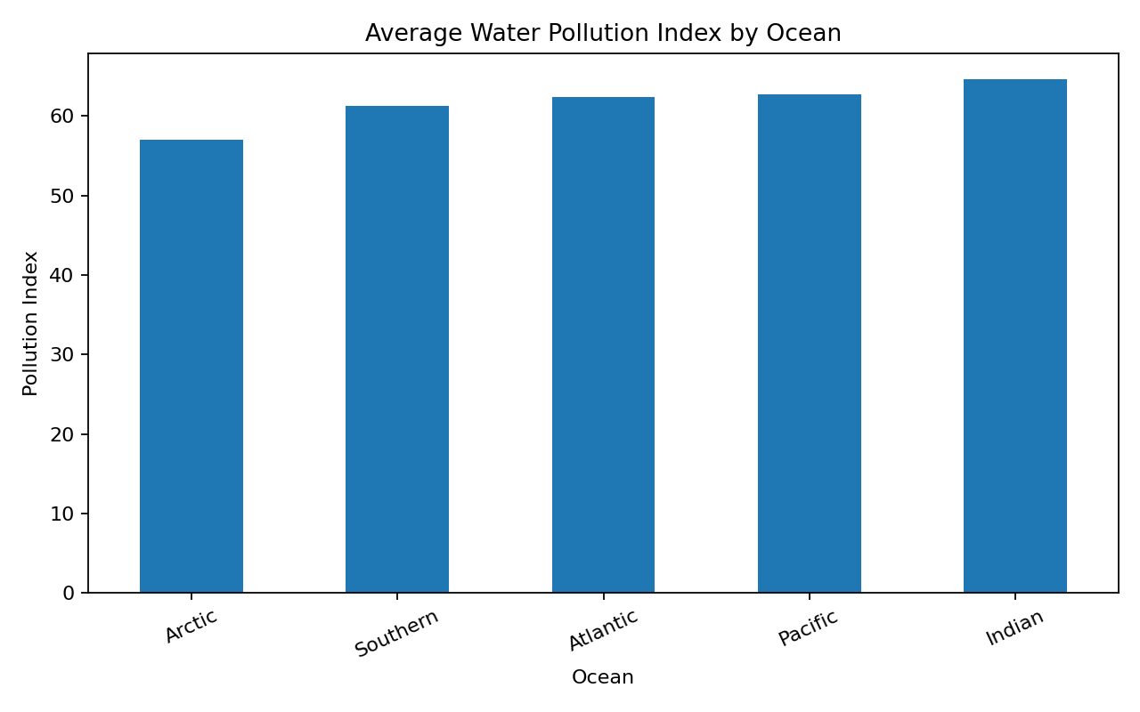
RESULT: The Ocean Pollution dataset was successfully analyzed and visualized using the specified technique.

